Domain Driven Design: Banking

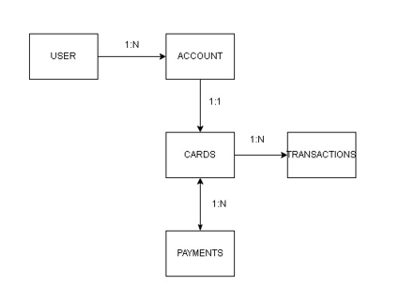

Description of the DDD (Domain driven design)

A DDD is a software development approach that focuses on designing software that reflects a business domain. It emphasizes understanding the business needs and using a common language between business stakeholders and developers.

Within a bank there are users who can have one or more accounts, each account has a card with which transactions are made such as purchases, withdrawals, payments, among others. To pay the credit card it is used a payment or deposit. In the case of the debit card you can use it for payments but under this context we will manage them as transactions.

Business Rules:

1. One user can have multiple accounts
2. One account only has one card
3. A card has multiple transactions
4. A card can has multiple payments
5. Every time a movement is made on the cards, it will be reflected on your account statement
6. To make a purchase with the debit card you need a positive balance and for the other one it will be necessary enough credit line
7. As we will be doing some purchases it would be necessary some data of the cards like card number, expiration date, NIP, CVV, card type and CLABE.
8. Every user will have some information in our systemlike ID, RFC, CURP, account number, name, birth date, address, phone, email and password
9. In the case of the account it is necessary an ID account, balance and credit line
10. For the the transactions an ID, reference, concept, amount, transaction date
11. And for the payments an ID of the payment, card ID, amount, concept and date